JavaScript Essentials and Advanced

Session 12 :

Open your browser's Developer Tools, go to the Network tab, and perform a fetch() GET request to https://jsonplaceholder.typicode.com/users. Take a screenshot showing the request and response details, and write two lines explaining the request-response cycle you observed.

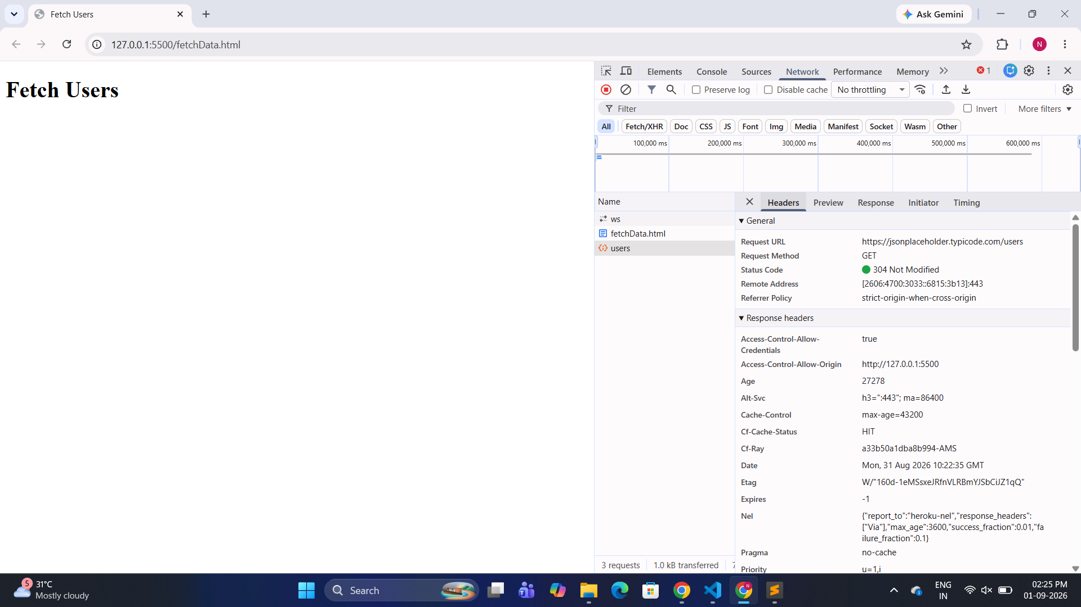

Explanation :
This page's fetch() call sent a GET request to the JSONPlaceholder API asking for the /users resource, and because the browser (or an intermediate cache, indicated by Cf-Cache-Status: HIT) already had a fresh cached copy matching the server's Etag, the server replied with 304 Not Modified instead of resending the full JSON body — telling the browser to reuse its cached data. This is a classic conditional-request optimization: it saves bandwidth since the actual user data only needs to be re-downloaded when it actually changes on the server.

One thing worth noting for your write-up: since the response was served from cache (304), your users array in the Console still populated correctly — the browser transparently substitutes the cached body even though the network response itself carried no payload.

Open your browser's DevTools Network tab, run a fetch() GET request to https://jsonplaceholder.typicode.com/users, and take a screenshot showing the request and response details. Briefly describe what you see in the request and response cycle.


Explanation

The browser sent a GET request to https://jsonplaceholder.typicode.com/users, and the server responded with status 304 Not Modified, meaning the previously cached response was still valid and was reused instead of downloading the data again. The response headers (Cache-Control, Etag, Age, Cf-Cache-Status: HIT) confirm this was a cache validation cycle rather than a fresh full download of the JSON payload.

If instead you want a screenshot showing a fresh 200 OK response with the actual JSON body (rather than a cached 304), you'd need to force-bypass the cache — check Disable cache in the Network tab (it's the checkbox right there in your toolbar) and re-run the fetch. That would show the full response body in the Preview/Response tab too. Let me know if that's what you're after and I can walk you through it.

